Technical Leadership Project
2008
Heather Carver
Department of Education and Training
10/31/2008
Strategic Intent

“To increase the use of ICT at Harrisfield Primary School”

In my role as an Ultranet coach with Southern Metropolitan Region, I am based at Harrisfield Primary School. As part of our work I chose to work more closely with Harrisfield who expressed a wish to increase the ICT use in the classroom programs. To gather a clear vision of what this might mean I explored my values and beliefs and how they aligned with those of the school and the wider school system.

Values and Beliefs

My values and beliefs
ICT should be an everyday part of every classroom.
ICT can make learning more fun.
ICT can make teaching easier.
ICT can make communicating and sharing easier.
Just about anything we want to do - can be done through a free online tool - or at the very least a low cost tool.

DEECD's values and Beliefs
DEECD’s values and beliefs are espoused in the Principles of Learning and Teaching (PoLT) and in the Victorian Essential Learnings (VELS)

PoLT
3.4 The teacher capitalises on students' experience of a technology rich world
Students come to classrooms with a variety of experiences of and expertise in contemporary technologies. This component encourages the exploration with students of their interest and expertise and the meaning they assign to technological communication, design and representation. It is about enlisting students' capabilities and interests associated with contemporary technologies.
6.3 The teacher uses technologies in ways that reflect professional and community practices
New technology challenges and changes the way we behave and learn in our contemporary society.. Learners need to develop a mastery of contemporary skills and techniques and their application through new media and new technologies. When used in ways that reflect their contemporary use, learning technologies can provide powerful stimulus for students to operate autonomously and develop expertise. Learners use a range of learning technologies to create new knowledge and understandings.

VELS
Standards in the Information and Communications Technology domain are organised in three dimensions.
- ICT for visualising thinking
- ICT for creating
- ICT for communicating.

Harrisfield PS’s Values and beliefs
- What does Harrisfield stand for?
- What do they really value?
- What do they purport to value?

Meredith Iaconese (School Principal) is a strong proponent of high ICT usage in the classroom. She believes she has several competent and keen teachers and a core of teachers who are anxious about technology and lacking in knowledge and skills required to make best use of the tools available.

She wished to up the profile of ICT, increase the knowledge and skills of her staff and improve the way in which ICT supports learning and teaching.

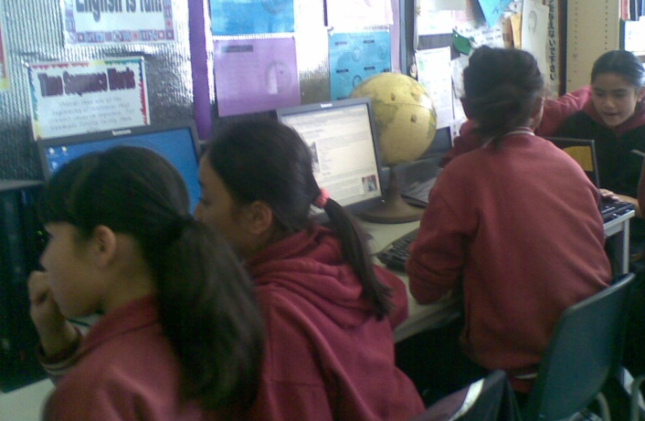

Strategic Plan
Major Strategies | Nature of Direction/Activity | Who | Key Outcomes | Time | Cost
Improve teacher ICT capacity | Present to whole staff on ePotential and assist them complete the survey and explore the resources.  Teachers to put an ICT goal in their performance plans  Work with individual or small teams of teachers as they implement their ICT goal (coaching/mentoring)  Short PD sessions at weekly staff meetings | Jono, Julian & Heather  Meredith  Heather, Julian & Jono  Meredith | 95% Staff complete ePotential survey  95% Staff have an ICT goal in their performance plan  Complete 2 sequences of ICT Peer coaching with at least 1 teacher | Term 1 2008  Term 1  1 year | nil
Implementation of Electronic whiteboard and increase usage of Interwrite tablets. | In conjunction with the Teaching and learning coaches - purchase an IWB for the meeting room.  Provide interactive software such as Easy teach for teachers to use.  Provide IWB training  Provide IWB PD sessions  Provide Interwite tablet PD & training sessions  Purchase further IWB's for classrooms | David Burton & Meredith  DI Morwood (T&L Coach)  Jonathan Hall | AT least 3 teachers trail the Interwrite pads in the classroom  One third of staff bring their class to the meeting room to use the IWB  One third of teachers using electronic whiteboard  All teachers using electronic whiteboards | 1 year  1 year  2 years  5 years
Increase access to and use of ICT in the classroom program | Set up an intranet or wiki to help make links more accessible for teachers when planning and providing online resources to students.  Increase use of the Digilearn objects, Rainbow Maths, Maths dictionary, etc | Heather  Sue Thomas, Heather | Wiki being used by 50% of staff for internal communication  Admin to be using intranet for most formal communication  50% of teachers to have posted work/ rubrics/directions/etc for students at least once.  An overall improvement in ePotential survey results | End of 2008  End of 2009  Mid 2008  Mid 2009
Build relationships within the staff to increase opportunity for mentoring, coaching, supporting and to eventually develop an ICT mentoring program within the Harrisfield staff. | Attend Tuesday morning staff - admin meetings whenever possible.  Attend staff functions - informal and formal. | Heather | 50% of staff feel less stressed by the need to increase ICT use.  50% of staff identified as needing mentoring - take up the opportunity. | Mid 2009 | nil
eLearning Plan | Assist Meredith to gather whole staff input to school elearning plan | MEREDITH, Heather, Jono, Julian | An elearning plan that reflects the schools needs and abilities  Majority of goals from plan met | End of term 3 2008  End of 2008 | Nil  ????

Observations and Outcomes

ICT integration in the Classroom Program
Following the ePotential presentation and survey in term 1, one teacher expressed an interest in doing Claymation with her class. Julian has some experience with this and I know the theory and how to use Movie maker. I offered to support her in this.
Claymation project has been integrated into a writing rotation based around Australian History - their SOSE theme at the time. She did quite a bit of research herself. She showed the classes several claymations the first session. The second she showed 2 and asked them to compare and contrast them. In the third session she had an outstanding sample from gr 5&6 at Essendon North, she asked the student to list the good points etc (She used a feedback pyramid). Throughout these sessions the groups began to research their topics, develop a timeline and rough story board.
Late term 2 2008, the schools Mathematics Teaching and Learning Coach (T&L) showed one of the teachers she is coaching, the Digilearn objects that relate to the settling of Australia - that linked with their Australian History Unit. She then came and asked for help to make them available to her class. This showed a real acceptance of these ideas, a preparedness to take on ICT despite a lack of confidence, and a trust in me to be able to help in a way that would be non threatening. The Principal gave us feedback that this was a fabulous step forward for this teacher and that she was delighted.

Electronic Internal Communication
We (the ultranet coaches) set up the school email account to be accessed in Outlook and then shared it with everyone on the Harrisfield distribution list. The Assistant Principal then moved from making a separate publisher file of the calendar each month and the school outlook calendar is now being used across the school as the official calendar. A Staff meeting date is coming up shortly where we will ensure that all staff members are using Outlook on their laptops - so they have instant access to this calendar (currently only about half do it this way.)

There has been a complete stall on the sharepoint front as the technician hit a snag and has not had time to come back to it. I will sit down with the Principal and discuss whether to go back to the wiki idea (which are already set up) or to push forward with Ash in the hope it is up and running for the start of 2009.
Interactive Whiteboard
Due to the enthusiasm and persistence of the T&L coach use of the IWB has increased greatly. She has been showcasing the IWB to teachers and grades outside of her "coaching grades". This has seen 3 – 4 of them make much more use of it. While there is still a need for challenge regarding the pedagogical use - it is only with practice and familiarity teachers will be confident enough to take on the next step.

Planning for the Future
eLearning planning has become a focus for term 4 with the Assistant Principal and the ICt co-ordinator attending a workshop held by Jono & Julian – the other Ultranet Coaches. The have begun their plan and immediately went back and worked on the eLearning vision with the whole staff. I have made an appointment for a 3 hr meeting with them both to take this through to completion so that it can feed into the AIP process - with the first draft due on Nov 30th.

Key Outcomes | Time | Achieved?
95% Staff complete ePotential survey  95% Staff have an ICT goal in their performance plan  Complete 2 sequences of ICT Peer coaching with at least 1 teacher | Term 1 2008  Term 1  1 year | Only one sequence but it went for 10 wks.
AT least 3 teachers trail the Interwrite pads in the classroom  One third of staff bring their class to the meeting room to use the IWB  One third of teachers using electronic whiteboard  All teachers using electronic whiteboards | 1 year  1 year  2 years  5 years
Wiki being used by 50% of staff for internal communication  Admin to be using intranet for most formal communication  50% of teachers to have posted work/ rubrics/directions/etc for students at least once.  An overall improvement in ePotential survey results | End of 2008  End of 2009  Mid 2008  Mid 2009 | *  * See Observations - Internal communications for more details explanation regarding the hold up in achieving this goal.
50% of staff feel less stressed by the need to increase ICT use.  50% of staff identified as needing mentoring - take up the opportunity. | Mid 2009
An elearning plan that reflects the schools needs and abilities  Majority of goals from plan met | End of term 3 2008  End of 2008

